|  |
| --- |
|  |
| Synchronization of Inspection and Geo Tagging Applications |
|  |
|  |
|  |
|  |

Table of Contents

1 Introduction 5

2 Objectives 5

3 Business Requirements 5

4 UI of Geotagging Application 5

5 UI of the Inspection Application 7

List of Figures

Figure 1: UI of Geotagging Application 6

Figure 2: UI of Inspection Application 7

Figure 3: Lease and Mine Names in Inspection App 8

Revision History

|  |  |  |  |
| --- | --- | --- | --- |
| **Name** | **Date** | **Reason for Changes** | **Version** |
| Ibrar Khan | 27-Dec-2022 | Initial Draft | 1.0 |
|  |  |  |  |
|  |  |  |  |
|  |  |  |  |
|  |  |  |  |
|  |  |  |  |
|  |  |  |  |
|  |  |  |  |
|  |  |  |  |
|  |  |  |  |
|  |  |  |  |
|  |  |  |  |
|  |  |  |  |
|  |  |  |  |
|  |  |  |  |
|  |  |  |  |
|  |  |  |  |
|  |  |  |  |

# Introduction

Chief Inspectorate of mines is using two mobile applications one for Geo Tagging and the other for performing Inspections. Currently, the inspection application is rendering Leases Data by importing excel sheet of leases from geotagging application.

# Objectives

Objectives of the module comprise

1. Using the geotagging application, reflect newly geotagged mines in inspection application against leases.

# Business Requirements

User-Friendly mobile applications are already developed by PITB for geotagging and inspections of mines against leases. Data of newly geotagged mines is not reflecting directly on the inspection application.

Here is a need to synchronize both applications. After synchronization data of the latest geotagged mine must reflect on the inspection application. So that inspectors could perform inspections on spot right after geotagging new mines.

# UI of Geotagging Application

Valid geotag users submit the details of mine needed to geotag. Highlighted Lease numbers and Mines must reflect in the inspection application upon submission.

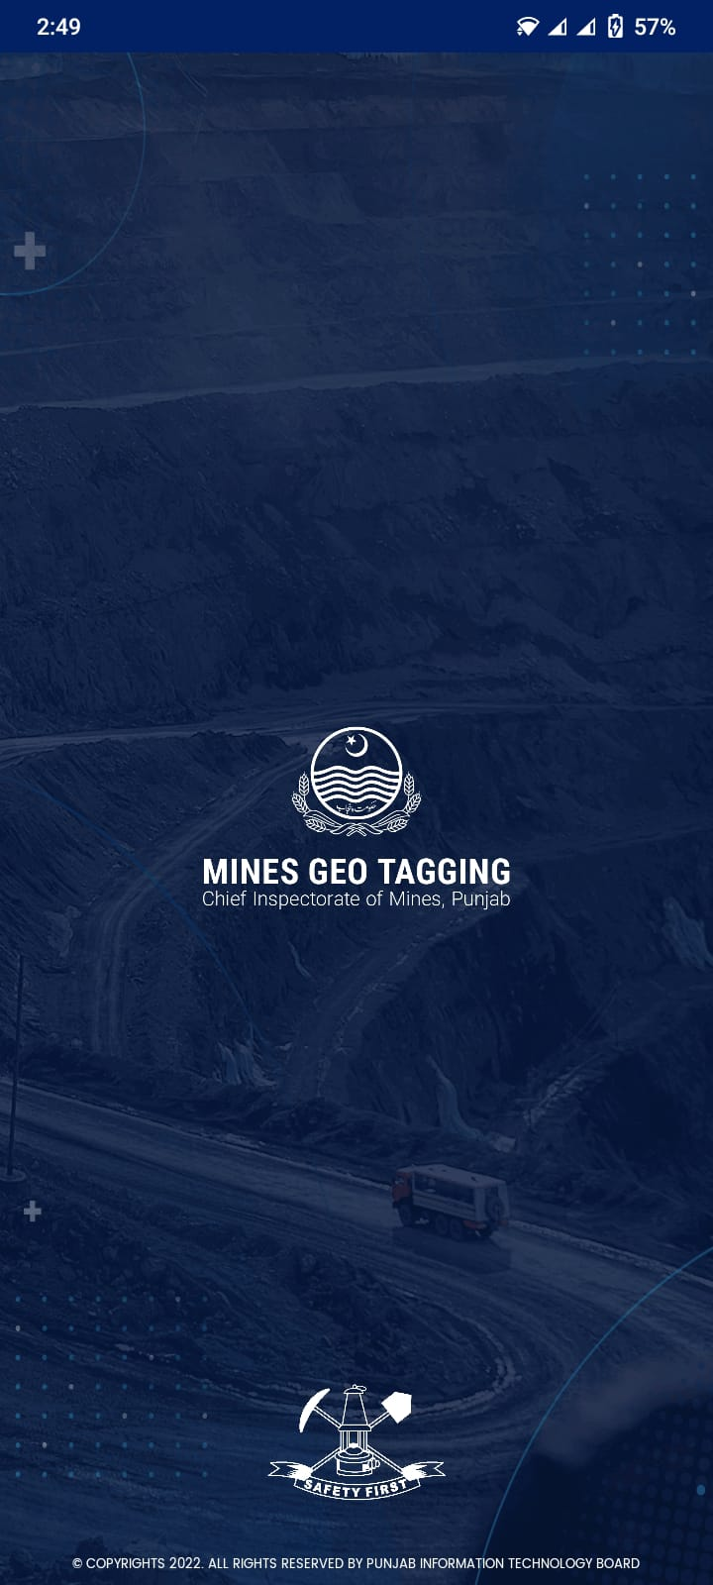 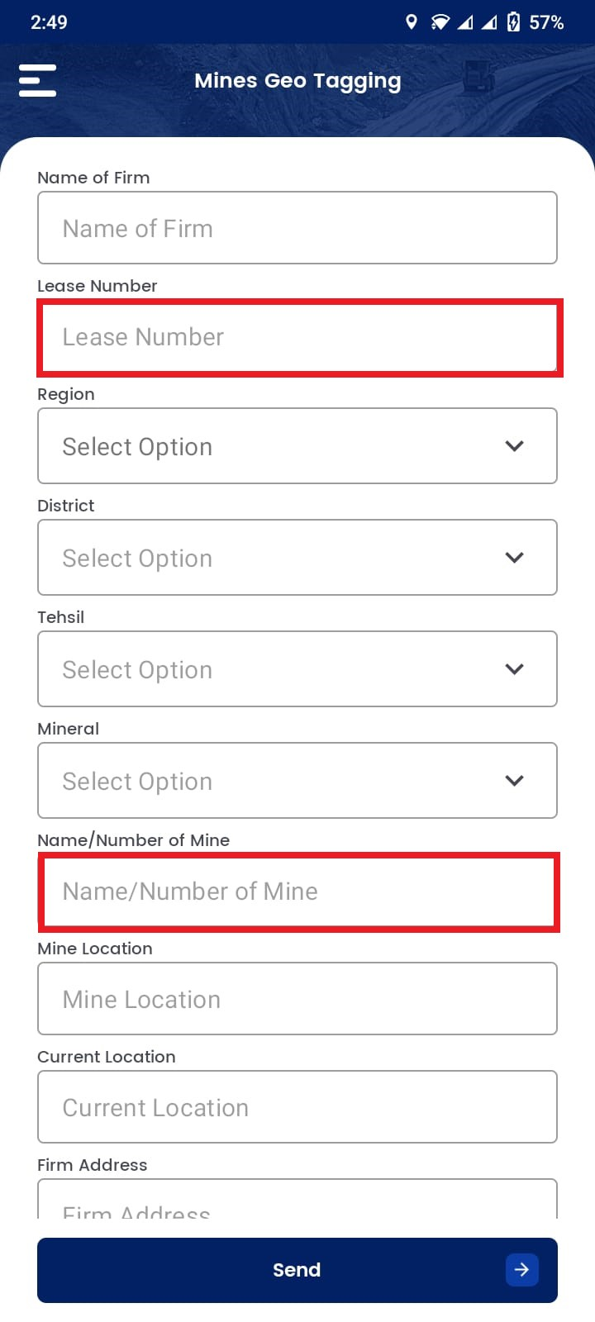

Figure : UI of Geotagging Application

# UI of the Inspection Application

Valid Inspecting officers perform the following inspection after login.

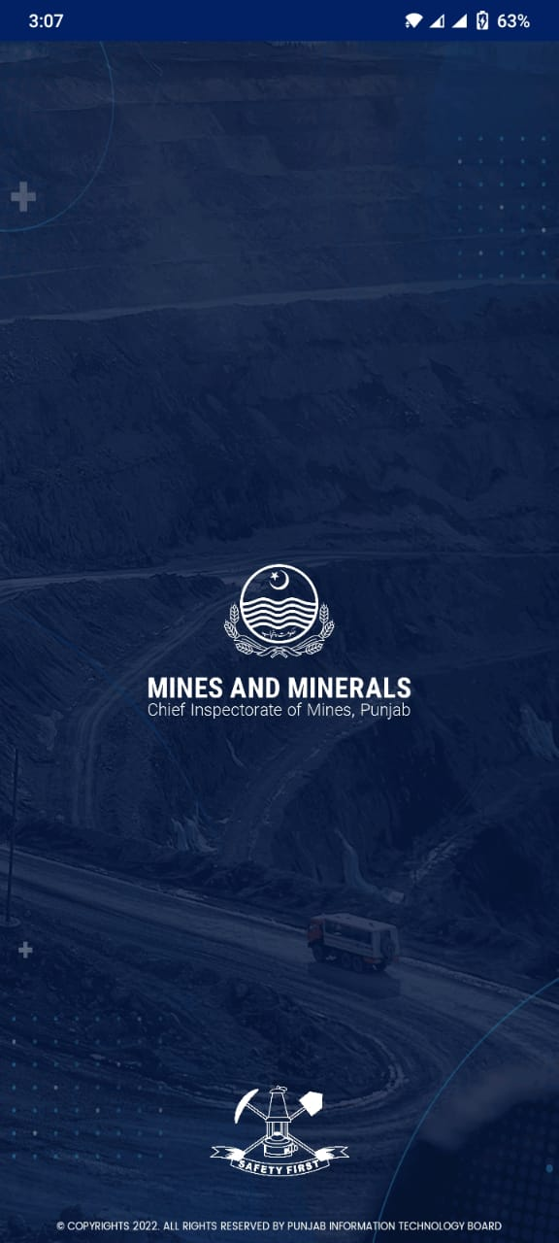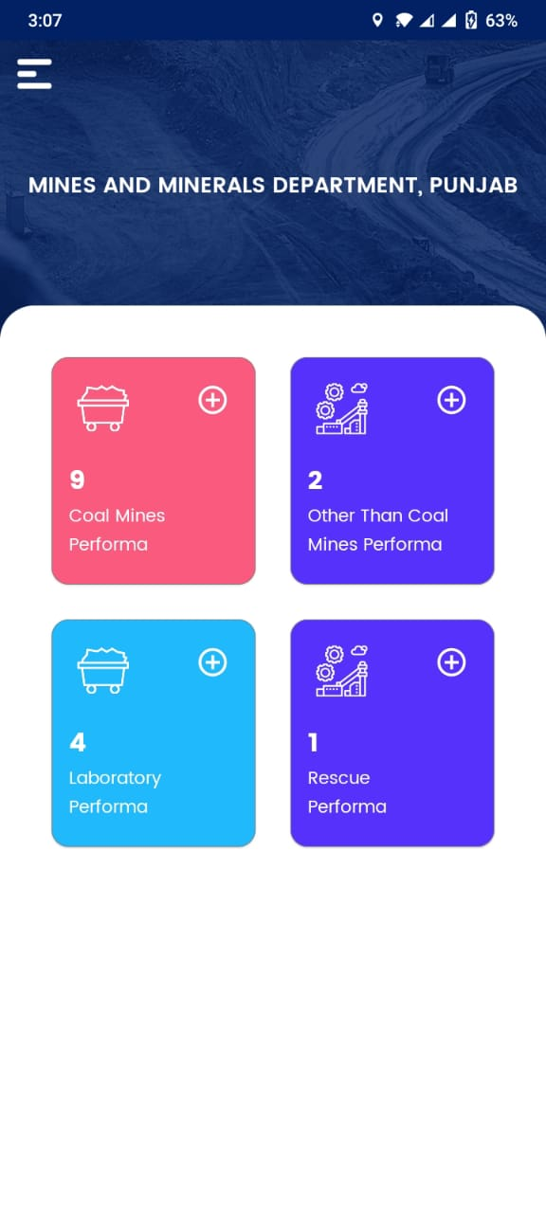

Figure : UI of Inspection Application

Upon selection of inspection type Performa e.g. Coal, Other than coal, etc. newly geotag mines must populate in the dropdown of Lease numbers and mines.

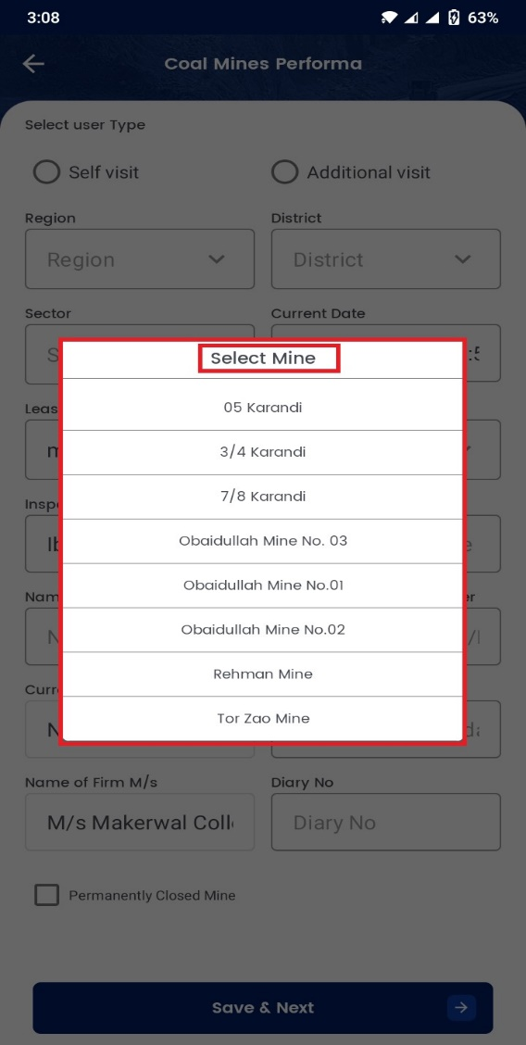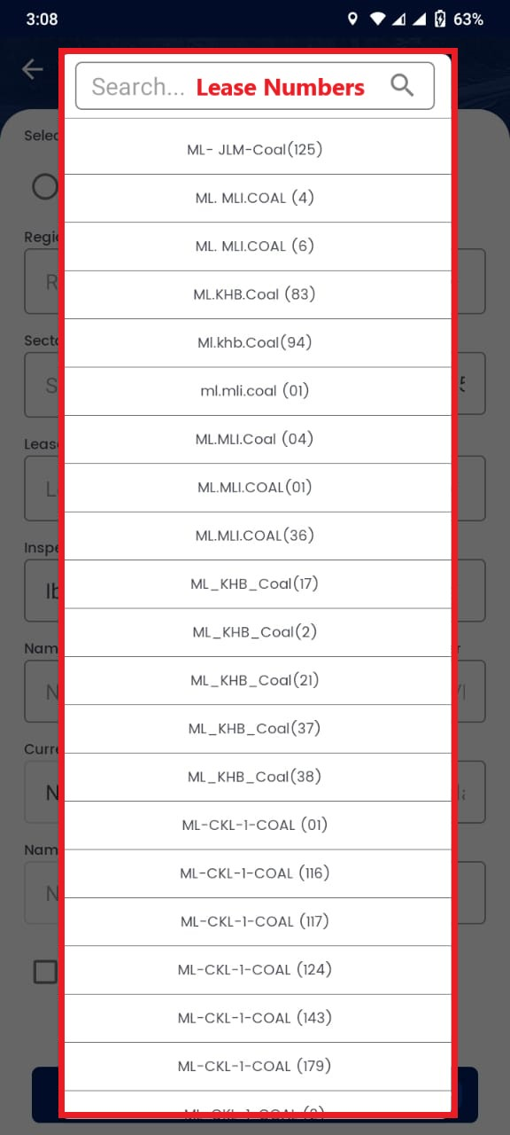

Figure : Lease and Mine Names in Inspection App